AI ASSISTED CODING LAB
ASSIGNMENT-13.2
ENROLLMENT NO :2503A51L30 BATCH NO: 19
NAME: BOLLEPALLY MAHESH
TASK DESCRIPTION 1: Remove Repetition
Task: Provide AI with the following redundant code and ask it to
refactor
Python Code
def calculate_area(shape, x, y=0):
if shape == "rectangle":
return x * y
elif shape == "square":
return x * x
elif shape == "circle":
return 3.14 * x * x
Expected Output
• Refactored version with dictionary-based dispatch or separate functions.
• Cleaner and modular design.
PROMPT: Provide AI with the following redundant code and ask it to refactor.
CODE GENERATED:

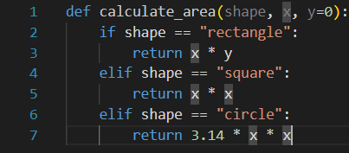

OUTPUT:
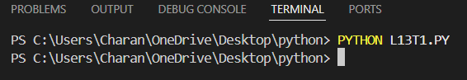

CORRECTED CODE:

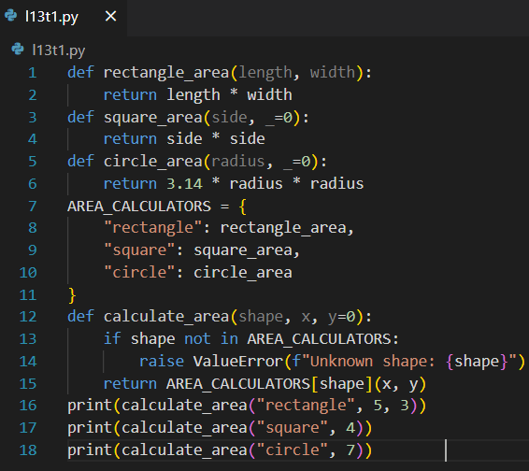
OUTPUT:
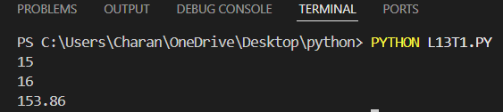

OBSERVATION: •
Repetition – The code repeats logic (x * x for both square and circle).
Inconsistent Parameters –
- rectangle uses both x and y.
- square and circle ignore y, which is confusing.
Hard to Extend – Adding new shapes means more elif blocks.
No Error Handling – Passing an unknown shape returns None.
Magic Number – Uses 3.14 instead of math.pi (less accurate)

TASK DESCRIPTION 2: Error Handling in Legacy Code
Task: Legacy function without proper error handling
Python Code
def read_file(filename):
f = open(filename, "r")
data = f.read()
f.close()
return data
Expected Output:
AI refactors with with open () and try-except
PROMPT: Refactor the following legacy Python function to add proper error handling. The current code opens a file without using a context manager and does not handle exceptions. Rewrite it using with open () and try-except blocks to make it safe and Pythonic.

CODE GENERATED:

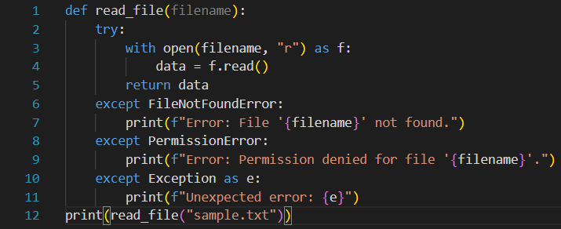
OUTPUT:
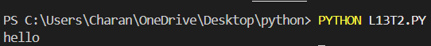
Observation
- The legacy code works only if the file exists and is readable. If the file is missing or inaccessible, it crashes with errors (FileNotFoundError, PermissionError, etc.).
- The refactored code uses with open () and try-except, so the file is safely closed and errors are handled gracefully with clear messages

TASK DESCRIPTION 3: Complex Refactoring
Task: Provide this legacy class to AI for readability and modularity improvements:
Python Code
class Student:
def __init__(self, n, a, m1, m2, m3):
self.n = n
self.a = a
self.m1 = m1
self.m2 = m2
self.m3 = m3
def details(self):
print("Name:", self.n, "Age:", self.a)
def total(self):
return self.m1+self.m2+self.m3
Expected Output:
• AI improves naming (name, age, marks).
• Adds docstrings.
• Improves print readability.
• Possibly uses sum(self.marks) if marks stored in a list
PROMPT: Refactor the legacy Student class to improve readability and modularity. Store marks in a list, use descriptive variable names (name, age, marks), add docstrings, and provide methods to display student details and calculate total marks.
CODE GENERATED:

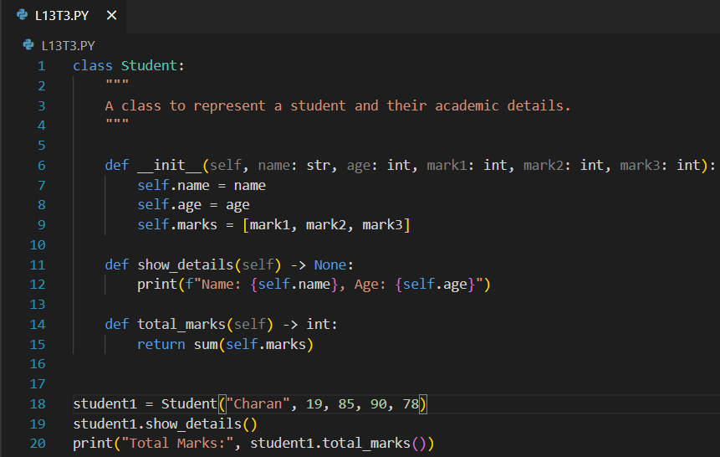

OUTPUT:
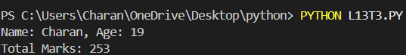
Observation:
- The class now has clear naming and docstrings.
- Marks are stored in a list, allowing easy sum calculation.
- Output is neatly formatted using f-strings.
- Methods show_details () and total_marks () work as expected.

TASK DESCRIPTION 4: Inefficient Loop Refactoring
Task: Refactor this inefficient loop with AI help
Python Code
nums = [1,2,3,4,5,6,7,8,9,10]
squares = []
for i in nums:
squares. append (i * i)
Expected Output: AI suggested a list comprehension

PROMPT: Refactor the following inefficient Python loop to make it more concise and Pythonic. The loop calculates the squares of numbers in a list. Suggest a version using list comprehension

CODE GENERATED:

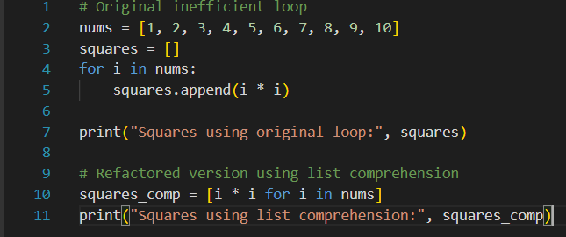
OUTPUT:
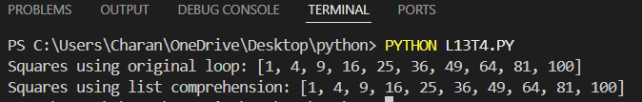
Observation:
- The original code uses a for loop and append () which is less concise.
- The refactored version is more Pythonic, concise, and often faster, using list comprehension.
- Output for both codes will be: [1, 4, 9, 16, 25, 36, 49, 64, 81, 100]

